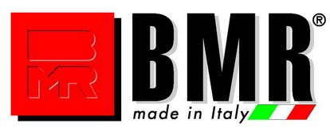
BMR S.p.A. - Via G. Fattori, 6 - 42019 Scandiano (RE) Italy -Tel. +39 0522 857868 - 985123 - Fax +39 0522 856475 - E-mail: bmr@bmr.it Internet: www.bmr.it
Cap.Soc.€ 500.000,00 i.v.- R.E.A. RE 185515–Mecc RE 008750- Numero C.E.E. IT 01431820354
Iscr. Reg. Impr. di RE 01431820354–C.F./P.IVA 01431820354

July 2019

CERAMIC END OF LINE IN MEXICO IS BRANDED BMR
The Central American country entrusts BMR with new ceramic finishing systems
and approves the company as a trusted partner.

BMR consolidates its leadership position in Mexico by undersigning new and important supplies with the main ceramic companies in the area.

The Interceramic ceramic company in Chihuahua, already in possession of 2 wet squaring lines and 1 lapping line with 2 Leviga machines with 12 heads and BMR’s Top Coat, renews its trust in the company from Scandiano by installing 1 dry cutting and squaring line with Top Squadra Dry 12/1 for porcelain stoneware, max. size of 1200x1200 mm.

Daltile Mexico (in Monterey) has chosen BMR as a supplier of 1 dry squaring line with Squadra Dry 9/1 for the Large Unit factory and 1 dry cutting and squaring line with Top Squadra Dry 12/1 for the Mini Pisos factory, both for max. size of 600x1200 mm.

Vitromex also relies on BMR for the San Luis Potosì (SLP) factory, where 2 dry cutting and squaring lines are installed with Top Squadra Dry 12/1 for a max. size of 1200x1200 mm and 2 dry cutting and squaring lines are installed with Top Squadra Dry 12/1 and 1 lapping line with Top Coat treatment for a max. size of 1200x1800 mm. At the Vitromex factory in Guanajuato, on the other hand, 1 BMR dry squaring line has been installed with Squadra Dry 9/1 and Diavision BMR for red body tiles with max. size of 600x1200 mm.

Lastly, the ceramic company Nitropiso (San Luis Potosì - SLP) has fitted its plant with 1 BMR dry cutting and squaring line with Squadra Dry 12/1 for max. size of 600x1200 mm.

Press Office
INtono Comunicazione / Silvia Bertolani
silvia.bertolani@intono.it
Cel +39 346 2365171

